**Bank Loan Report Query Document**

1. **Bank Loan Report | Summary**

**KPI’s :**

**Total Loan Application**

SELECT count(id) as Total_Loan_Applications from bank_loan_db



**Month to date total number of applications**

SELECT count(id) as MonthTD_TotalLoan_Applications from bank_loan_db

WHERE MONTH(issue_date)=12 and YEAR(issue_date)=2021



**Previous month to date total number of applications**

SELECT count(id) as PMTD_TotalLoan_Applications from bank_loan_db

WHERE MONTH(issue_date)=11 and YEAR(issue_date)=2021



**Total Funded Amount**

Select sum(loan_amount) as Total_Funded_Amount from bank_loan_db



**Month to date total funded amount**

Select sum(loan_amount) as MonthTD_Total_Funded_Amount from bank_loan_db

where MONTH(issue_date)=12 and YEAR(issue_date)=2021



**Previous Month to date total funded amount**

Select sum(loan_amount) as PMTD_Total_Funded_Amount from bank_loan_db

where MONTH(issue_date)=11 and YEAR(issue_date)=2021



**Total Amount Received**

Select sum(total_payment) as Total_Amount_Received from bank_loan_db



**Month to date total amount received**

Select sum(total_payment) as MonthTD_Total_Amount_Received from bank_loan_db

where MONTH(issue_date)=12 and YEAR(issue_date)=2021



**Previous Month to date total amount received**

Select sum(total_payment) as PMTD_Total_Amount_Received from bank_loan_db

where MONTH(issue_date)=11 and YEAR(issue_date)=2021



**Avg int rate**

Select round(avg(int_rate),4)*100 as Avg_Intrate from bank_loan_db



**Month to date avg int rate**

Select round(avg(int_rate),4)*100 as MonthTD_Avg_Intrate from bank_loan_db

where MONTH(issue_date)=12 and YEAR(issue_date)=2021



**Previous Month to date avg int rate**

Select round(avg(int_rate),4)*100 as PMTD_Avg_Intrate from bank_loan_db

where MONTH(issue_date)=11 and YEAR(issue_date)=2021



**Avg dti**

Select round(avg(dti),4) *100 as Avg_DTI from bank_loan_db



**Month to date avg dti**

Select round(avg(dti),4) *100 as MonthTDAvg_DTI from bank_loan_db

where month(issue_date)=12 and YEAR(issue_date)=2021



**Previous Month to date avg dti**

Select round(avg(dti),4) *100 as PMTDAvg_DTI from bank_loan_db

where month(issue_date)=11 and YEAR(issue_date)=2021



**Good Loan Issued**

**Good Loan Percentage**

Select (count(CASE when loan_status='Fully Paid' or loan_status='Current' then id end )*100)

/ count(id) as GoodLoanPercentage

from bank_loan_db



**Good Loan Applications**

Select count(id) as GoodLoanApplications

from bank_loan_db

where loan_status='Fully Paid' or loan_status='Current'



**Good Loan Funded Amount**

select sum(loan_amount) as GoodLoan_Funded_Amount from bank_loan_db

where loan_status='Fully Paid' or loan_status='Current'



**Good Loan Received Amount**

select sum(total_payment) as GoodLoan_Received_Amount from bank_loan_db

where loan_status='Fully Paid' or loan_status='Current'



**Bad Loan Issued**

**Bad loan Percentage**

select (count(Case when loan_status='Charged Off' then id end)*100.0)

/ count(id) as BadLoanPercentage

from bank_loan_db



**Bad loan Application**

select count(id) as BadLoanApplication from bank_loan_db

where loan_status='Charged Off'



**Bad loan Funded Amount**

select sum(loan_amount) from bank_loan_db

where loan_status='Charged Off'



**Bad loan Amount Received**

select sum(total_payment) from bank_loan_db

where loan_status='Charged Off'



**Loan Status**

**Full Year Loan Status**

SELECT loan_status,

COUNT(id) AS LoanCount,

SUM(total_payment) AS Total_Amount_Received,

SUM(loan_amount) AS Total_Funded_Amount,

AVG(int_rate * 100) AS Interest_Rate,

AVG(dti * 100) AS DTI

FROM

bank_loan_db

GROUP BY

loan_status

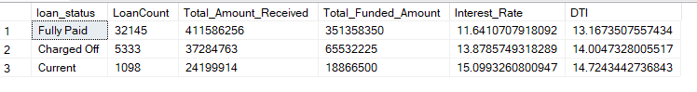

**Month to date Loan Status**

SELECT

loan_status,

SUM(total_payment) AS MTD_Total_Amount_Received,

SUM(loan_amount) AS MTD_Total_Funded_Amount

FROM bank_loan_db

WHERE MONTH(issue_date) = 12

GROUP BY loan_status

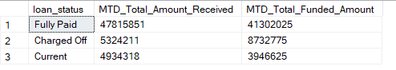

1. **Bank Loan Report**

**Month**

SELECT

MONTH(issue_date) AS Month_Munber,

DATENAME(MONTH, issue_date) AS Month_name,

COUNT(id) AS Total_Loan_Applications,

SUM(loan_amount) AS Total_Funded_Amount,

SUM(total_payment) AS Total_Amount_Received

FROM bank_loan_db

GROUP BY MONTH(issue_date), DATENAME(MONTH, issue_date)

ORDER BY MONTH(issue_date)

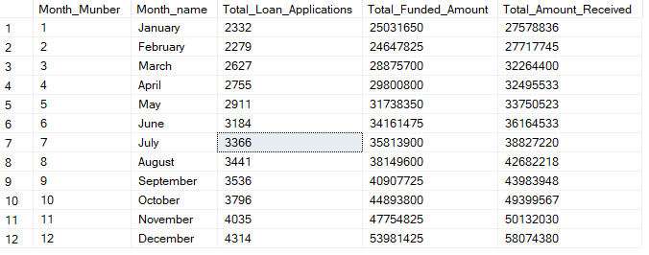

**State**

SELECT

address_state,

COUNT(id) AS Total_Loan_Applications,

SUM(loan_amount) AS Total_Funded_Amount,

SUM(total_payment) AS Total_Amount_Received

FROM bank_loan_db

GROUP BY address_state

ORDER BY address_state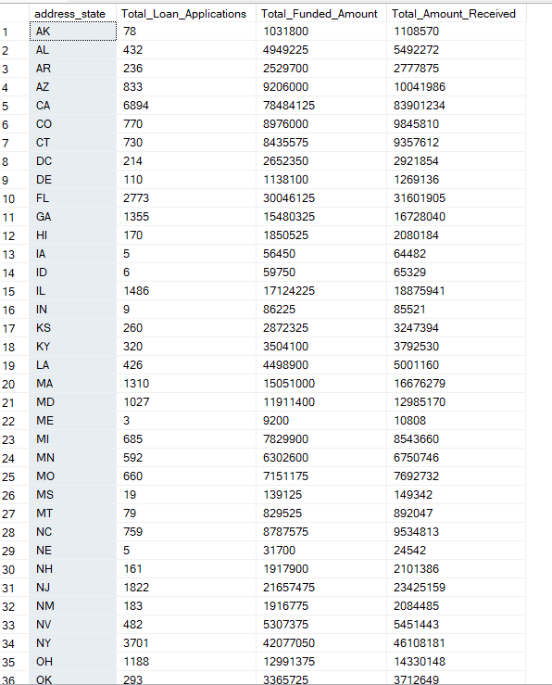

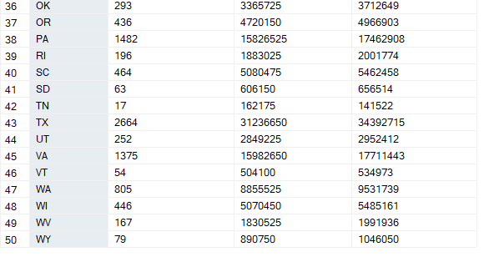

**Term**

SELECT

term,

COUNT(id) AS Total_Loan_Applications,

SUM(loan_amount) AS Total_Funded_Amount,

SUM(total_payment) AS Total_Amount_Received

FROM bank_loan_db

GROUP BY term

ORDER BY term

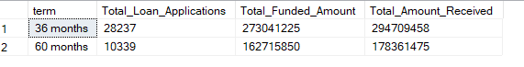

**Emp Length**

SELECT

emp_length,

COUNT(id) AS Total_Loan_Applications,

SUM(loan_amount) AS Total_Funded_Amount,

SUM(total_payment) AS Total_Amount_Received

FROM bank_loan_db

GROUP BY emp_length

ORDER BY emp_length

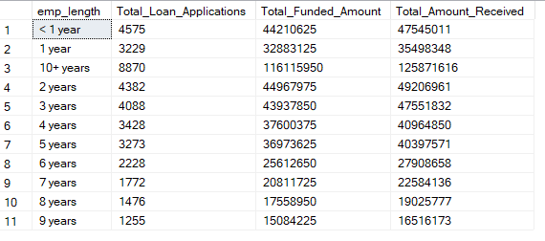

**Purpose**

SELECT

purpose,

COUNT(id) AS Total_Loan_Applications,

SUM(loan_amount) AS Total_Funded_Amount,

SUM(total_payment) AS Total_Amount_Received

FROM bank_loan_db

GROUP BY purpose

ORDER BY COUNT(id) desc

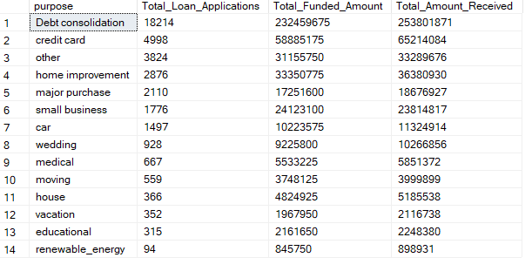

**Home Ownership**

SELECT

home_ownership,

COUNT(id) AS Total_Loan_Applications,

SUM(loan_amount) AS Total_Funded_Amount,

SUM(total_payment) AS Total_Amount_Received

FROM bank_loan_db

GROUP BY home_ownership

ORDER BY COUNT(id) desc

